

**Name**: Zaka ullah (L1F22MSDS0010)

**Subject**: Tools and techniques

**Submitted by**: Respect Saeed Iqbal Khathak

**Assignment: How to install the Apache Spark?**

Here is the major steps which we have to follow to install the apache spark

1. A system running Windows 10.
2. Verifying Java Installation.
3. Verifying Scala Installation.
4. Downloading Scala.
5. Installing Scala.
6. Downloading Apache Spark
7. Installing Spark.
8. Verifying the Spark Installation.

**Download the Java:**

* Once the download finishes, run the file.

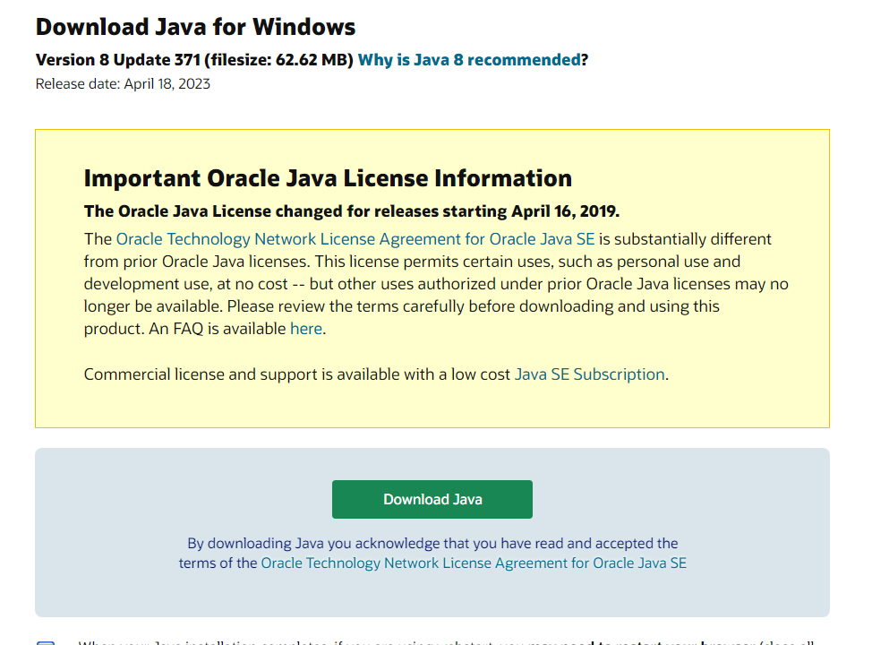

**Verify java by running below command**



**Install Python:** (latest version [Python 3.10.12](https://www.python.org/downloads/release/python-31012/))

<https://www.python.org/downloads/>

* setup the folder named (Python)
* Once the download finishes, run the file.

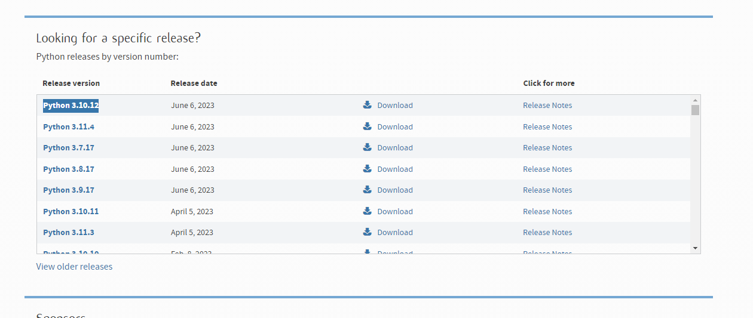

**Verify the python version:**

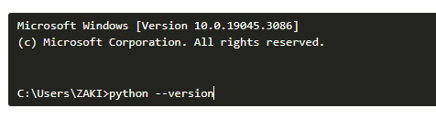

**Download Apache spark:**

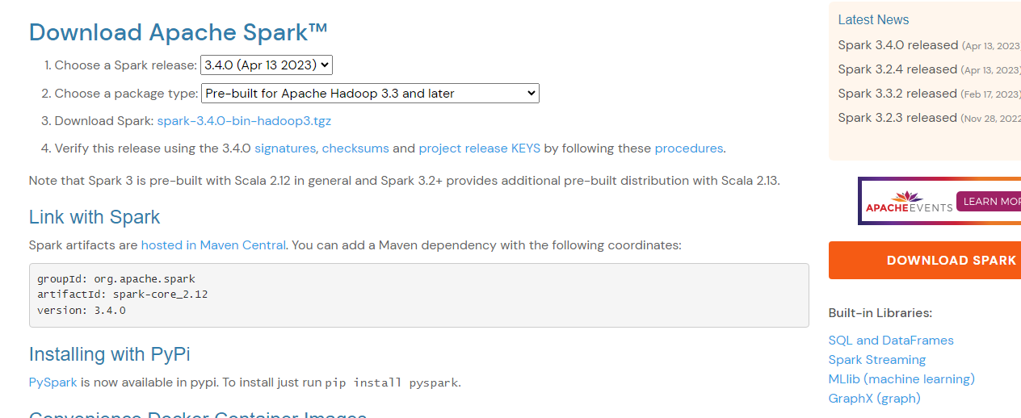

**Extract spark:**

$ tar xvf spark-1.3.1-bin-hadoop2.6.tgz

**Move Spark files:**

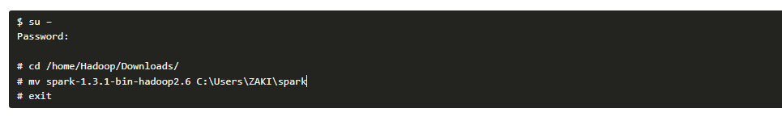

**Setup the environment:**

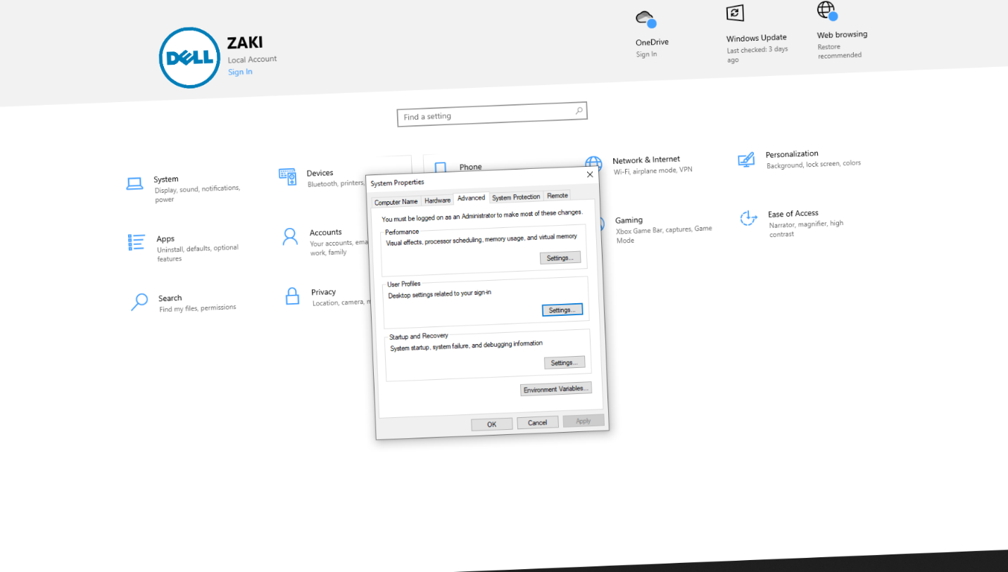

**Verify Spark installation:**

**Run the command (**$spark-shell**):**

